Vulcan Activity Tracker
Weekly Report



Week 2
Team Members:
Margo Bonal
John Gerega
Luke Ruffing

Professor:
Dr. Weifeng Chen

Course: CMSC-4920-Senior Project II
School: Pennsylvania Western University
Project: Vulcan Activity Tracker
During the 2025-2026 winter break between the semester terms, our senior project group took initiative to begin research and development processes of our project. Team discussions were held to share gathered information and propose implementation ideas.
Goals Accomplished:
The first goal was to create a welcome page for the Vulcan Activity Tracker. This page is the web application entry point and the first impression of a user. Cohesive design begins on the welcome page, setting the scale and design for following pages. The welcome page provides a small informative section on what the app will do, available features, and PennWest California athletic environments that will be spotlighted in the app.
The second goal was the creation of the docker container and Mssql database that will power the Vulcan Activity Tracker. This proved to be the most challenging part of development to date. Docker containers and Mssql had a steep learning curve for our team. We not only needed to learn how to create and install the container/volume but also learn implementation syntax and commands. The set up took 2 weeks of initialization, testing, debugging, and revisions. Multiple docker configurations were implemented to find a final solution.
The third goal over winter break was to design a user create account form and login portal. There were four steps involved for this goal: Creating HTML user portal, collecting/encrypting data, API configuration, and database storage. Our team researched encryption methods to formulate best solution that combined speed and safety. Argon2 Password Hasher paired with SHA-256 hashing was combined to make a two-step hashing algorithm of one fast and one slow hash. By pre-hashing the user’s password on the client side with the fast SHA-256, security can be ensured while transporting the password to the server side. Raw data is therefore never sent across the API. SHA-256 also allows for quick rendering for user experience. The user will feel like the platform reacts quickly to them. The second hash is performed on the server side of the application. Argon2 is a much slower hashing algorithm. It takes its time to ensure GPU, ASIC, rainbow, and Parallel attacks. The computation time is fractionally greater, this is why we perform it on the server side. Our team has agreed that this encryption format meets the needs of the Vulcan Activity Tracker and data safety. Combining two matching hashes with an additional Salt introduces a layered encryption architecture to ward off attacks.
Problems:
A critical problem was found during the initial development process. Team device chip configuration was not considered when choosing a database driver to implement. The MSSQL 2022 server version 17 was not compatible with ARM 64 computer chips, since it was Intel Specific. Considerable research was done to problem solve a solution. Virtual machines were far too financially and computationally costly. They also required advanced knowledge that was unattainable within time constraints. Another considered solution was purchasing an intel laptop for team members. This also proved to be too costly both financially and in laptop dependency set up time.
Solutions:
The final solution was acquired by finding a compatible MSSQL database driver installation that was compatible on both ARM64 and X 86 Intel. This version is the MSSQL – Azure Edge, or version 18. There is a slight trade off in build performance, however, it is the only version compatible for all team members devices.
Team Progress Vs. Gantt Chart:
According to our Group 2 Gantt chart, our team is ahead of schedule, due to winter break project advancement. However, with database and API complexity, scheduling must continue at the same pace to avoid falling behind schedule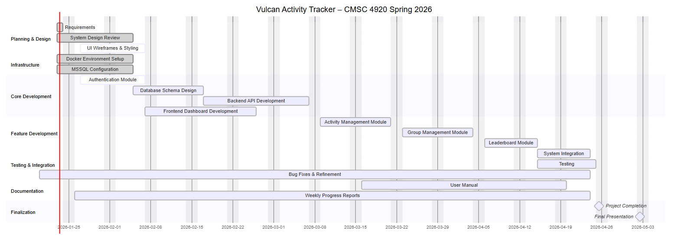
This Week Plan:
This week’s team plan is to finalize platform color schemes and finish the first concept of the dashboard. This will then allow for the planning and creation of all needed dashboard database tables. We would like to additionally begin the creation of Activity records. This includes the user interfacing, data transfer, and database schema storage. The final goal of this week is to fix login unique username bugs.

Member Contribution:
Margo Bonal:
- Docker Initialization
- MSSQL set up
- Welcome Page
- Login Pages/API/Hashing
- User DB creation
- Team meetings
- Week 2 Report and Slides
John Gerega:
- Dashboard page
- Extended base templates for all additional pages
- Color scheme
- Leaderboard initialization
- Team meetings
Luke Ruffing:
- Team meeting
- Syntax and system study
- Learn GitHub branching policies
- Gantt Chart

